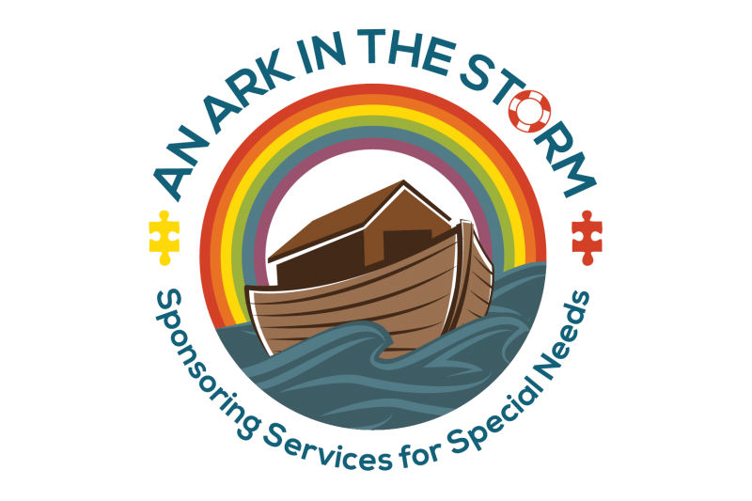

Oils on the Ark

Hello,

As a mother of four young children ages 2-8 (including two athletes and one child with special needs) and the owner of a therapy agency, I was looking for a more natural and safe way to take care of my family's (and my clients' families') health and wellness. I was introduced to Young Living and it has been such a blessing in my life! Their products are all non-toxic and safe for all members of the family (even pets!) and they have it all – from therapeutic grade essential oils to toothpaste to laundry detergent and supplements. I am happy to share my love for this company and their products by presenting you with this free sample bag.

All gift bags include a sample of Thieves non-toxic, all natural whole home cleaner. This is amazing! One great way to improve the air quality in your home is to ditch the toxic cleaners and replace them with this alternative, which works just as well without catalyzing asthma and respiratory issues.

You also received one of these five oils. Here are some ideas on how to use them:

Lavender – Great for relaxation! Rub some on the feet of your little one who can't settle down. Add a few drops to your favorite unscented lotion to ease dry skin. Put a few drops in your bathwater after a rough day or place a few drops on a cotton ball and place on the night stand.

Copaiba – Great for sore muscles! Add a few drops to unscented lotion to create an effective massage cream. Add to bathwater for all-over aches or add a few drops to a spray bottle of water and spritz your sheets before bed.

Frankincense – My go-to oil for almost anything! Rub a drop at the base of the neck for concentration, add a few drops to a cotton ball beside the bed during meditation. Relax and ground yourself by putting a few drops in your bath water.

Stress Away – What parent doesn't need this one!? Rub a few drops on your wrists or the back of the neck to ease tension. Diffuse or add to cotton balls to create a calm environment or unwind with this one in your bath.

Panaway – Great for pain relief! Create a massage cream by adding it to your favorite unscented lotion. If the area in pain is too sensitive, you can rub panaway on the feet and still feel the effects.

I hope you enjoy your gift! If you want more information about Young Living please visit my website or email me. I would love to hear how much you enjoyed your gift!

With Love, Joni

Email: joni@anarkinthestorm.org Website: www.anarkinthestorm.org/oils

